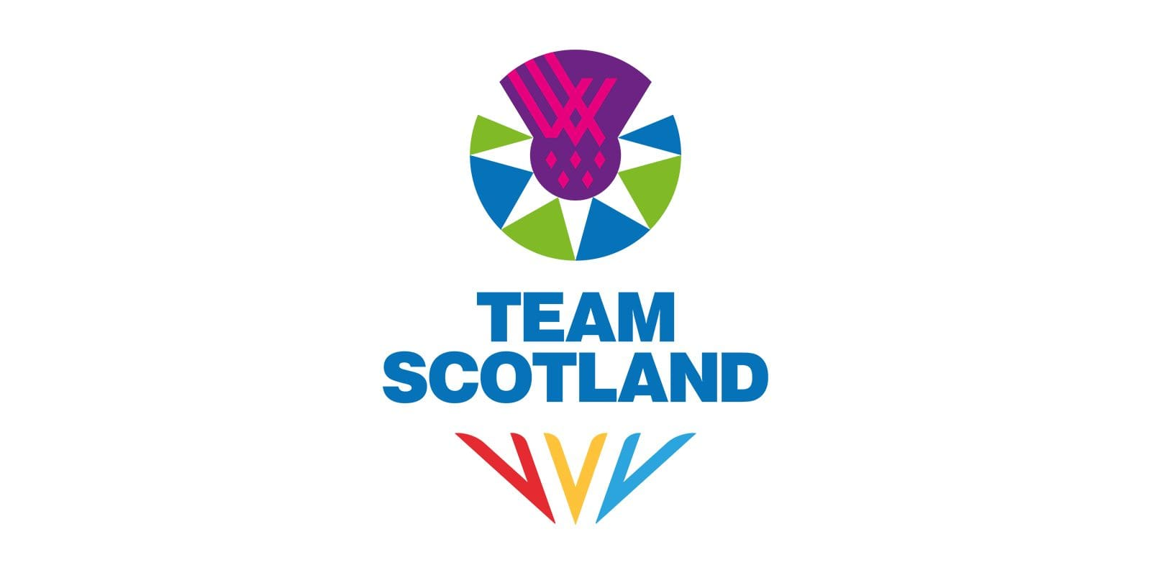
RECRUITMENT PACK
SOCIAL MEDIA EXECUTIVE

ABOUT US
Commonwealth Games Scotland (CGS) is the lead body for Commonwealth sport in Scotland. We select, prepare and lead Team Scotland at the Commonwealth Games and Commonwealth Youth Games.

Our Vision: Team Scotland and the Commonwealth Games inspiring Scotland to be physically active and successful in the sporting arena.

Our Mission: Use our unique position in Scottish sport to lead and maximise the benefits for Scotland, our member sports and athletes by:

- Enabling Team Scotland athletes to perform to their potential at the Commonwealth Games and Commonwealth Youth Games
- Making the nation proud
- Operating in a fair and inclusive way

ABOUT THE ROLE
We are seeking to recruit Social Media Executives to join Team Scotland’s media and communications team for the XXIII Commonwealth Games in Glasgow, taking place from 23 July to 2 August 2026.
Reporting to the Digital Manager, the Social Media Executive will play a key role in planning, scheduling and publishing content across Team Scotland’s social media channels throughout the Games. This position is central to delivering timely, engaging and well-coordinated digital output that showcases Team Scotland’s athletes, stories and achievements to audiences in Scotland and around the world.
The successful candidate will be responsible for planning and scheduling daily social content in line with the wider communications plan, ensuring posts are accurate and aligned with brand tone and messaging. They will oversee the day-to-day running of content calendars, liaise with photographers, videographers and the wider digital team to gather required assets and ensure content is prepared for posting across all platforms. The role will also involve supporting reactive content needs during competition, contributing ideas to enhance engagement, and providing input into daily planning meetings to help shape the overall social media narrative during the Games.
Applicants should demonstrate strong organisational and communication skills, attention to detail and the ability to react quickly in a fast-paced live event environment. Experience within a digital team, familiarity with social media management tools and an understanding of platform best practice would be advantageous, as would basic graphic and video editing skills. Creativity, reliability, sound judgement and a proactive approach to teamwork are essential, along with a genuine interest in digital content and sport.
This is an unpaid position, suited to someone who can make this commitment alongside existing employment or as part of their current professional responsibilities.

THE PROCESS
To apply, please email your CV and a covering letter detailing your relevant experience, skills and suitability for the role to media@teamscotland.scot by midday Monday, 1st December 2025.

Interviews will be held virtually on w/c 8th December.

Any enquiries regarding the post should be directed to media@teamscotland.scot

We are open to applications from individual applicants or service provision from agencies, provided a named individual is put forward for the role. We are happy to consider secondments and/or flexible working arrangements – please include this in your cover letter when applying.

Candidates are also requested to complete the anonymous equality monitoring form: Equality Monitoring Form

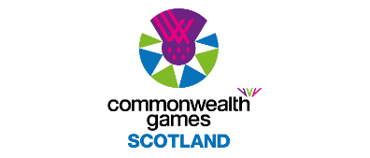

ROLE DESCRIPTION
Role Title: | Social Media Executive
Reports to: | Digital Manager
Responsible for: | N/A
Term: | 23 July – 2 August 2026 plus approx. 10 days through 2026
Hours: | Full time for during the Games, between 23rd July and 2nd August 2026 with exact dates to be confirmed depending on roles.  In addition to the Games time period detailed above, it is anticipated that there will be work amounting to approximately 10 days through 2026 including attendance at both the Staff Team Camp on 27-28 February and the full Team Camp on 1 July. This will involve a combination of daytime, evening and weekend working.  It should be noted that this is an unpaid position and as such would suit an individual who can perform the role as part of an agreed release from their existing employer. For those not in such a position, we would welcome your expression of interest and a further conversation around your circumstances and opportunity to be part of the team. Pre-agreed reasonable expenses will be met.
Location: | Glasgow
Key Responsibilities: | Pre-Games  Attend team meetings and training activities as required prior to the Games.  Familiarise with Team Scotland’s digital channels, brand guidelines and messaging ahead of Games time.  Familiarise with digital asset sharing system, including tagging and distribution protocol.  Contribute to the social media plan for the pre- and during-Games period.  Familiarise with Glasgow 2026 sports, selected athletes and liaise with the wider digital and media team as required.  During Games  Assist with the set up and break down of Team Scotland’s media and digital operations areas.  Plan, schedule and publish social media content across Team Scotland’s channels, ensuring all posts are accurate, timely and aligned with the wider communications plan.  Manage the social media content calendar, maintaining an organised system for upcoming posts, required assets and deadlines.  Monitor social channels for messages, comments and engagement, triaging enquiries and directing them to the relevant team members as appropriate.  Maintain accurate records of published content, campaign performance and daily activity to support efficient reporting and content planning.  Provide general support to the Digital Manager and broader digital team, including uploading approved content and contributing ideas and updates to daily team meetings.  Liaise with content creators, photographers, videographers and other media team members to ensure prompt access to assets and smooth coordination of day-to-day social media activity  Post-Games  Attend post Games Team Scotland/CGS functions e.g. media or celebration events as required.  Contribute to the communications de-brief report.
Skills and Experience: | Proven organisational skills with excellent attention to detail, particularly when planning and scheduling content across multiple platforms.  Experience creating, managing or scheduling social media content, ideally within a sport, media or events environment.  Familiarity with social media management tools, content calendars and platform best practice is desirable.  Strong written and verbal communication skills, with the ability to craft clear, concise and engaging social copy.  Ability to prioritise tasks and work effectively under pressure during live events and fast-moving situations.  Basic skills in graphics creation and/or video editing are desirable.  A proactive, flexible attitude and willingness to support a variety of content and administrative tasks across the digital team.  An interest in social media, digital storytelling and sport, and enthusiasm for contributing to Team Scotland’s success at the Games.  Team members should expect to work long hours and be capable of operating effectively in a high-pressure environment as part of a small, focused team.
Remuneration and Benefits: | Voluntary role.  Reasonable expenses incurred in carrying out this position are reimbursed, in line with the CGS Expenses Policy.  Games-time travel, accommodation, subsistence and kit will be provided, as well as appropriate accreditation to fulfil the responsibilities of the role.

