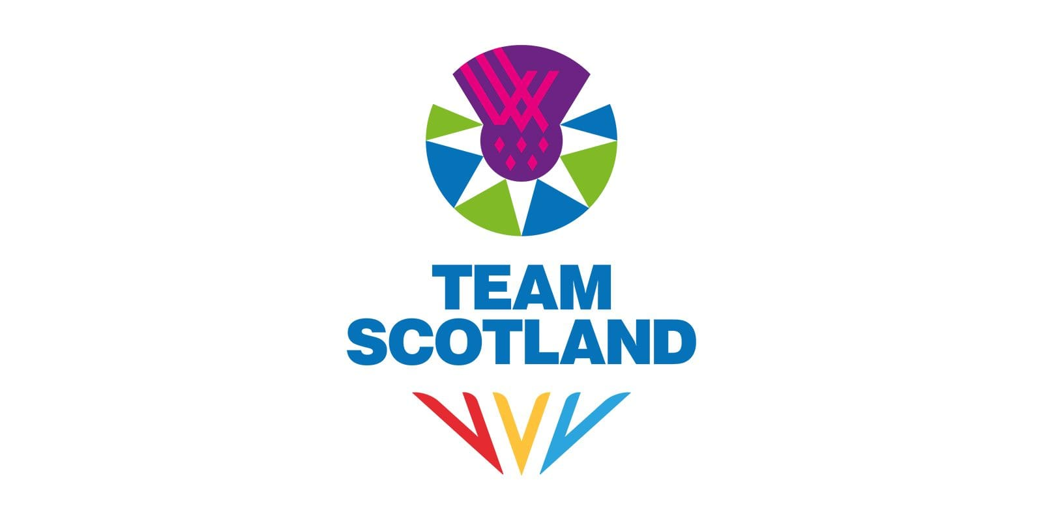
RECRUITMENT PACK
DIGITAL ADMINISTRATOR

ABOUT US
Commonwealth Games Scotland (CGS) is the lead body for Commonwealth sport in Scotland. We select, prepare and lead Team Scotland at the Commonwealth Games and Commonwealth Youth Games.

Our Vision: Team Scotland and the Commonwealth Games inspiring Scotland to be physically active and successful in the sporting arena.

Our Mission: Use our unique position in Scottish sport to lead and maximise the benefits for Scotland, our member sports and athletes by:

- Enabling Team Scotland athletes to perform to their potential at the Commonwealth Games and Commonwealth Youth Games
- Making the nation proud
- Operating in a fair and inclusive way

ABOUT THE ROLE
We are seeking to recruit a Digital Administrator to join Team Scotland’s media and communications team for the XXIII Commonwealth Games in Glasgow, taking place from 23 July to 2 August 2026.
Reporting to the Digital Manager, the Digital Administrator will play a key role in supporting the digital media team to ensure the smooth running of day-to-day operations throughout the Games. This position is central to maintaining an organised and efficient digital environment, helping to showcase Team Scotland’s athletes and activities to audiences in Scotland and around the world.
The successful candidate will be responsible for managing and maintaining the team’s digital assets, including filing, tagging and archiving images and video content to ensure easy retrieval and accurate record-keeping. They will oversee the media inbox, managing incoming enquiries, distributing messages to relevant team members and ensuring timely, professional responses. The role will also involve providing general administrative support to the wider digital and communications team to ensure all digital outputs run smoothly and efficiently throughout the Games period.
Applicants should demonstrate strong organisational and administrative skills, attention to detail and the ability to manage multiple priorities in a fast-paced environment. Experience working with digital asset management systems, file tagging or media databases would be advantageous, as would familiarity with email management tools and office software. Excellent communication skills, discretion and a proactive approach to teamwork are essential, along with a keen interest in digital media and sport.
This is an unpaid position, suited to someone who can make this commitment alongside existing employment or as part of their current professional responsibilities.

THE PROCESS
To apply, please email your CV and a covering letter detailing your relevant experience, skills and suitability for the role to media@teamscotland.scot by midday Monday, 1st December 2025.

Interviews will be held virtually on w/c 8th December.

Any enquiries regarding the post should be directed to media@teamscotland.scot

We are open to applications from individual applicants or service provision from agencies, provided a named individual is put forward for the role. We are happy to consider secondments and/or flexible working arrangements – please include this in your cover letter when applying.

Candidates are also requested to complete the anonymous equality monitoring form: Equality Monitoring Form

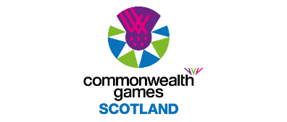

ROLE DESCRIPTION
Role Title: | Digital Administrator
Reports to: | Digital Manager
Responsible for: | N/A
Term: | 23 July – 2 August 2026 plus approx. 10 days through 2026
Hours: | Full time for during the Games, between 23rd July and 2nd August 2026 with exact dates to be confirmed depending on roles.  In addition to the Games time period detailed above, it is anticipated that there will be work amounting to approximately 10 days through 2026 including attendance at both the Staff Team Camp on 27-28 February and the full Team Camp on 1 July. This will involve a combination of daytime, evening and weekend working.  It should be noted that this is an unpaid position and as such would suit an individual who can perform the role as part of an agreed release from their existing employer. For those not in such a position, we would welcome your expression of interest and a further conversation around your circumstances and opportunity to be part of the team. Pre-agreed reasonable expenses will be met.
Location: | Glasgow
Key Responsibilities: | Pre-Games  Attend team meetings and training activities as required prior to the Games.  Familiarise with the Team Scotland website CMS, including news, athlete profiles and media galleries sections, ahead of Games time.  Familiarise with digital asset sharing system, including tagging and external distribution protocol.  Familiarise with Team Scotland’s media specific inbox and regular contacts.  Familiarise with sports on the Glasgow 2026 programme, selected athletes and liaise with the wider digital and media team as required.  During Games  Assist with the set up and break down of media office.  Manage and maintain the digital media team’s filing systems, ensuring all images, videos and other assets are correctly tagged, labelled and archived.  Oversee the media inbox, triaging and responding to enquiries, and distributing messages to relevant team members in a timely and professional manner.  Maintain accurate records and databases to ensure efficient access to digital materials and information.  Provide general administrative support to the Digital Manager and digital team members, including assisting with basic content management tasks, ensuring updates and uploads are completed accurately and on time.  Liaise with content creators, photographers and other media team members to support effective communication and collaboration across the media operation.  Post-Games  Attend post Games Team Scotland/CGS functions e.g. media or celebration events as required.  Contribute to the communications de-brief report.
Skills and Experience: | Proven organisational and administrative skills, with excellent attention to detail and accuracy.  Experience managing digital assets, file systems or databases, ideally within a media, events or communications environment.  Familiarity with digital asset management systems, file tagging and naming conventions is desirable.  Strong written and verbal communication skills, with a professional and courteous approach to handling enquiries.  Ability to prioritise tasks and work effectively under pressure in a fast-paced, team-based environment.  Proficiency in standard office software (e.g. Microsoft 365, Google Workspace) and comfort with basic digital tools.  A proactive, flexible attitude and willingness to support a variety of tasks across the digital media function.  An interest in digital media, communications and sport, and enthusiasm for contributing to Team Scotland’s success at the Games.  Team members should expect to work long hours and be capable of operating effectively in a high-pressure environment, as part of a small, focused team.
Remuneration and Benefits: | Voluntary role.  Reasonable expenses incurred in carrying out this position are reimbursed, in line with the CGS Expenses Policy.  Games-time travel, accommodation, subsistence and kit will be provided, as well as appropriate accreditation to fulfil the responsibilities of the role.

