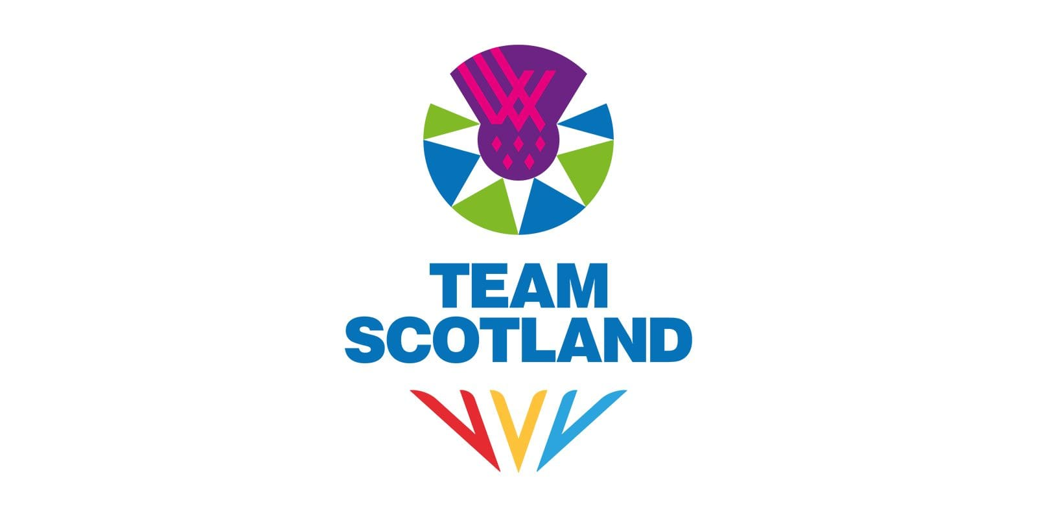
RECRUITMENT PACK
CONTENT CREATOR

ABOUT US
Commonwealth Games Scotland (CGS) is the lead body for Commonwealth sport in Scotland. We select, prepare and lead Team Scotland at the Commonwealth Games and Commonwealth Youth Games.

Our Vision: Team Scotland and the Commonwealth Games inspiring Scotland to be physically active and successful in the sporting arena.

Our Mission: Use our unique position in Scottish sport to lead and maximise the benefits for Scotland, our member sports and athletes by:

- Enabling Team Scotland athletes to perform to their potential at the Commonwealth Games and Commonwealth Youth Games
- Making the nation proud
- Operating in a fair and inclusive way

ABOUT THE ROLE
We are seeking to recruit Content Creators to join Team Scotland’s media and communications team for the XXIII Commonwealth Games in Glasgow, taking place from 23 July to 2 August 2026.
Reporting to the Digital Manager, Content Creators will play a key role in capturing high-quality video and photography throughout the Games and transforming this material into engaging content for Team Scotland’s social media channels. You will be out on the ground capturing moments and producing creative, shareable content that brings the nation closer to the athletes and showcases their journey across Team Scotland’s platforms.
The successful candidate will be responsible for filming and photographing daily activity, gathering behind-the-scenes moments, informal interviews and editing this material into platform-ready content. They will work closely with the wider digital team to ensure all content aligns with the overall communications plan and brand tone. Responsibilities will include producing short-form videos, reels and image sets, supporting reactive content needs during live competition, and contributing creative ideas that help elevate engagement and shape the overall social narrative during the Games.
Applicants should demonstrate strong creative and technical skills, excellent organisation, and the ability to work quickly and confidently in a fast-paced live event environment. Experience in video and photo capture, basic editing skills, familiarity with social media trends and formats, and an understanding of platform best practice would be advantageous. Creativity, reliability, sound judgement and a collaborative mindset are essential, along with a genuine interest in digital storytelling and sport.
This is an unpaid position, suited to someone who can make this commitment alongside existing employment or as part of their current professional responsibilities

THE PROCESS
To apply, please email your CV and a covering letter detailing your relevant experience, skills and suitability for the role to media@teamscotland.scot by midday Monday, 1st December 2025.

Interviews will be held virtually on w/c 8th December.

Any enquiries regarding the post should be directed to media@teamscotland.scot

We are open to applications from individual applicants or service provision from agencies, provided a named individual is put forward for the role. We are happy to consider secondments and/or flexible working arrangements – please include this in your cover letter when applying.

Candidates are also requested to complete the anonymous equality monitoring form: Equality Monitoring Form

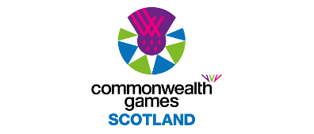

ROLE DESCRIPTION
Role Title: | Content Creator
Reports to: | Digital Manager
Responsible for: | N/A
Term: | 23 July – 2 August 2026 plus approx. 10 days through 2026
Hours: | Full time for during the Games, between 23rd July and 2nd August 2026 with exact dates to be confirmed depending on roles.  In addition to the Games time period detailed above, it is anticipated that there will be work amounting to approximately 10 days through 2026 including attendance at both the Staff Team Camp on 27-28 February and the full Team Camp on 1 July. This will involve a combination of daytime, evening and weekend working.  It should be noted that this is an unpaid position and as such would suit an individual who can perform the role as part of an agreed release from their existing employer. For those not in such a position, we would welcome your expression of interest and a further conversation around your circumstances and opportunity to be part of the team. Pre-agreed reasonable expenses will be met.
Location: | Glasgow
Key Responsibilities: | Pre-Games  Attend team meetings and training activities as required prior to the Games.  Familiarise with digital asset sharing system, including tagging and external distribution protocol.  Contribute to the pre-Games communications activity plan.  Familiarise with relevant sport team managers, selected athletes, and liaise with Sports Governing Bodies (SGB) sports-specific press officers as required.  Work with colleagues to shape and execute our Marketing and Communications Strategy, capturing content which engages, informs and inspires our audiences.  Capture and produce content for the Team Scotland social channels that will be used to promote our athletes, sports and partners both in real-time and for legacy purposes, as well as other Team Scotland activities.  Attend select events, taking responsibility for content capture  Support the wider marketing & communications team in delivering media and marketing commitments, if required.  During Games  Assist with the set up and break down of media office.  Capture high-quality social content for various projects  Plan, ideate and capture social content in conjunction with the digital and social team  Collaborate with the creative team to develop content concepts for social platforms such as Instagram and TikTok.  Conduct interviews with athletes, frinds, family and supporters (eg. Event Mixed Zone, Team Scotland House) and capture b-roll footage as needed  Edit content for social using apps such as Cap Cut as required  Post-Games  Maximise opportunities for promotion post-Games, including supporting the delivery of post-Games social content, wrap-up, events and activity.  Attend post Games Team Scotland/CGS functions e.g. media or celebration events as required.  Contribute to the communications de-brief report.
Skills and Experience: | Proven experience as a content creator or similar role  Experience in capturing content for mobile with experience in using editing apps such as Cap Cut or similar  Creative mindset with an eye for detail and understanding of how to engage audiences on social media platforms such as Instagram and TikTok  Excellent communication and collaboration skills  Ability to work under tight deadlines and manage multiple projects  Familiarity with sports on the Glasgow 2026 programme is desirable.  Applicants must be well organised, work in a structured manner, be resourceful, and be good team players.  Team members should expect to work long hours and be capable of operating effectively in a high-pressure environment, as part of a small, focused team.
Remuneration and Benefits: | Voluntary role.  Reasonable expenses incurred in carrying out this position are reimbursed, in line with the CGS Expenses Policy.  Games-time travel, accommodation, subsistence and kit will be provided, as well as appropriate accreditation to fulfil the responsibilities of the role.

